**ABSTRACT**

Our main objective of project is to make an ideal software to maintain information about events and to protect user data and to save the valuable time of the user. This project fulfils the requirement of user. The purpose of this system is to make the user experience of using this system a very good one. This system is used to store the data of all the events in a centralized system.

**List of Figures**

Figure 1: E-R Diagram

Figure 2: Class Diagram

Figure 3: Use-Case Diagram

Figure 4.1: DFD (Level-0)

Figure 4.2: DFD (Level-1)

Figure 4.3: DFD (Level-2)

Figure 5: Activity Diagram

Figure 6: Sequence Diagram

Figure 7: Empathy Canvas

Figure 8: Ideation Canvas

Figure 9: Product Development Canvas

Figure 10: AEIOU Canvas

**CHAPTER: 1**

**INTRODUCTION**

**1.1 PROJRCT SUMMARY**

Planning and managing events can be a challenging process, which can lead to a whole range of positive outcomes for the individual and the organizations. So, we decided to make a project

about the event management. This event management system can manage all the information about the various events systematically and also provides the security for the information.

**1.2 AIMS AND OBJECTIVES**

The objective of this application is to develop a system that effectively manages

all the data related to the various events that take place in an organization. The purpose is

to maintain a centralized database of all event related information. The goal is to support

various functions and processes necessary to manage the data efficiently.

**1.3 PROBLEM SPECIFITION**

The existing system is not providing secure registration and profile management

of all the users properly. The existing system is not providing on-line Help. This manual system gives us very less security for saving data and some data may be lost due to mismanagement. This

system is not providing event management through internet. This system is not providing

proper events information. The system is giving manual information through the event

management executer.

**1.4 Plan of Work**

Planning is one of the most important project management and time management techniques. Planning is preparing a sequence of action steps to achieve some specific goal. If we do it effectively, we can reduce much the necessary time and effort of achieving the goal.

A plan is like a map. When following a plan, we can always see how much we have progressed towards our project goal and how far we are from our destination. Knowing where we are is essential for making good decisions on where to go or what to do next.

We wanted to do something which is useful for the successful management of an event. So, we decided to make project related to Event Management.

After this we started with analysis phase. We analyzed all the current system both manual and automatic. So now after completing analysis phase we gathered basic requirement of our project as much as we can initial phase. Then we decided the flow of our system and how we would brake system in modules. Now as per the time restriction we decided to get the work done with efficiently as well as within given time period.

Work done in 7th Semester is shown below:

1. Project definition selection
2. Literature review and find out the problems in the existing system
3. Requirement gathering and analysis for the proposed system
4. Preparing AEIOU framework for the proposed system
5. Preparing Empathy map canvas for the proposed system
6. Preparing Ideation Canvas for the proposed system
7. Preparing Product Development Canvas for the proposed system
8. Preparing Database Design (DATA DICTIONARY and ER diagram) for the proposed system
9. Preparing UML diagrams for the proposed system
10. Preparing Report for the proposed system

**1.5 TECHNOLOGIES AND TOOLS:**

* ASP.Net MVC Framework
* Microsoft Visual Studio
* My SQL
* Windows Device
* C#, Bootstrap

**CHAPTER: 2**

**SYSTEM ANALYSIS**

**2.1 SOFTWARE MODEL**

Our Project is being developed using specific software development lifecycle. Software development approach is best suited for the project depends on the requirements and other factors. A process model is a development strategy that is used to achieve a goal that satisfies the requirements biding by the constraints.

There are many types of software process models like:

* Waterfall Model
* Iterative Model
* Incremental Model
* Spiral Model

**A spiral model has 4 phases:**

1. Planning phase
2. Risk analysis phase
3. Engineering phase
4. Evaluation phase

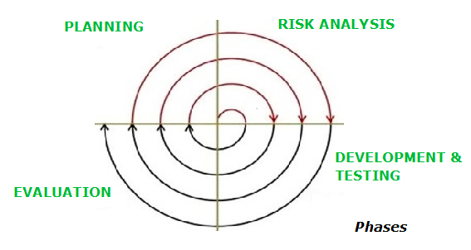

**Planning**:

-Requirements are studied and gathered.  
- Feasibility study.  
- Reviews and walkthroughs to streamline the requirements.

-Requirements understanding document.  
-Finalized list of requirements.

**Risk Analysis:**

-Requirements are studied and brain storming sessions are done to identify the potential risks.  
-Once the risks are identified, risk mitigation strategy is planned and finalized.

-Document which highlights all the risks and its mitigation plans.

**Engineering:**

-Actual development and testing if the software takes place in this phase.

-Code.  
-Test cases and test results.  
-Test summary report and defect report.

**Evaluation:**

-Customers evaluate the software and provide their feedback and approval.

-Features implemented document.

**2.2MODULESPECIFICATION**

**System Modules:**

**Event Manager**

* + Registration
  + Login
  + Add User
  + Add Event
  + Edit Data

**Administrator**

* + Handling of System

**2.3 FEASIBILITY STUDY**

A feasibility study covers an approximation of the level of proficiency necessary for a project and who can provide it, quantifiable and qualitative appraisal of other crucial resources, detection of important points, a common timetable, and a common cost estimate.

Whether a project is doable or not, i.e. whether it can spawn an equal or a higher rate of return during its lifetime needs a detailed research of existing disbursement. The prelude blueprint is the simple depiction of the discovering idea with a hint of the major factors to be measured in the study.

Various types of this that are frequently well thought-out include technical, operational, and economic feasibilities.

**Technical feasibility** standardizes the latest support (such as hardware and computer software) and expertise, which are essential to achieve client necessities in the computer software within the allocated time and finances. For this, the software development team rectify whether the present possessions and skill can be updated or additional in the computer software to achieve precise user necessities

**Operational feasibility** assesses the extent to which the required software executes a string of steps to crack business harms and user necessities. This feasibility is reliant on human assets (software development team) and relate visualizing whether the computer software will operate after it is developed and be functioning once it is installed.

**Economic feasibility** assesses whether the vital software is proficient of inducing monetary increment for an organization. It relates the cost subjected on the software development team, predictable cost of hardware and computer software, cost of conduct feasibility study, and others. For this, it is vital to believe expenses made on buy ups (such as hardware purchase) and actions requisite to bring out software development. In addition, it is compulsory to reflect on the benefits that can be attained by developing the software.

**2.4 ENVIRONMENT DESCRIPTION**

**2.4.1 HARDWARE AND SOFTWARE REQUIRMENTS**

**Hardware Requirements:**

Minimum Hardware Requirement is shown below:

* Processor: Intel Core i3 (minimum)
* RAM: Minimum 1 GB
* Hard disk: Minimum 40 GB
* Windows System(optional)

**Software Requirements:**

Minimum Software Requirement is shown below:

* Windows 7 or Above
* Microsoft Visual Studio
* My SQL Database
* Languages: HTML, C#

**CHAPTER: 3**

**SYSTEM DESIGN**

**3.1 FUNCTIONAL DIAGRAMS**

**3.1.1 E-R DIAGRAM**

An **entity-relationship (ER) diagram**, is a graphical demonstration of entities and their associations to each other, normally used in deducting in regard to the association of data within databases or information systems.

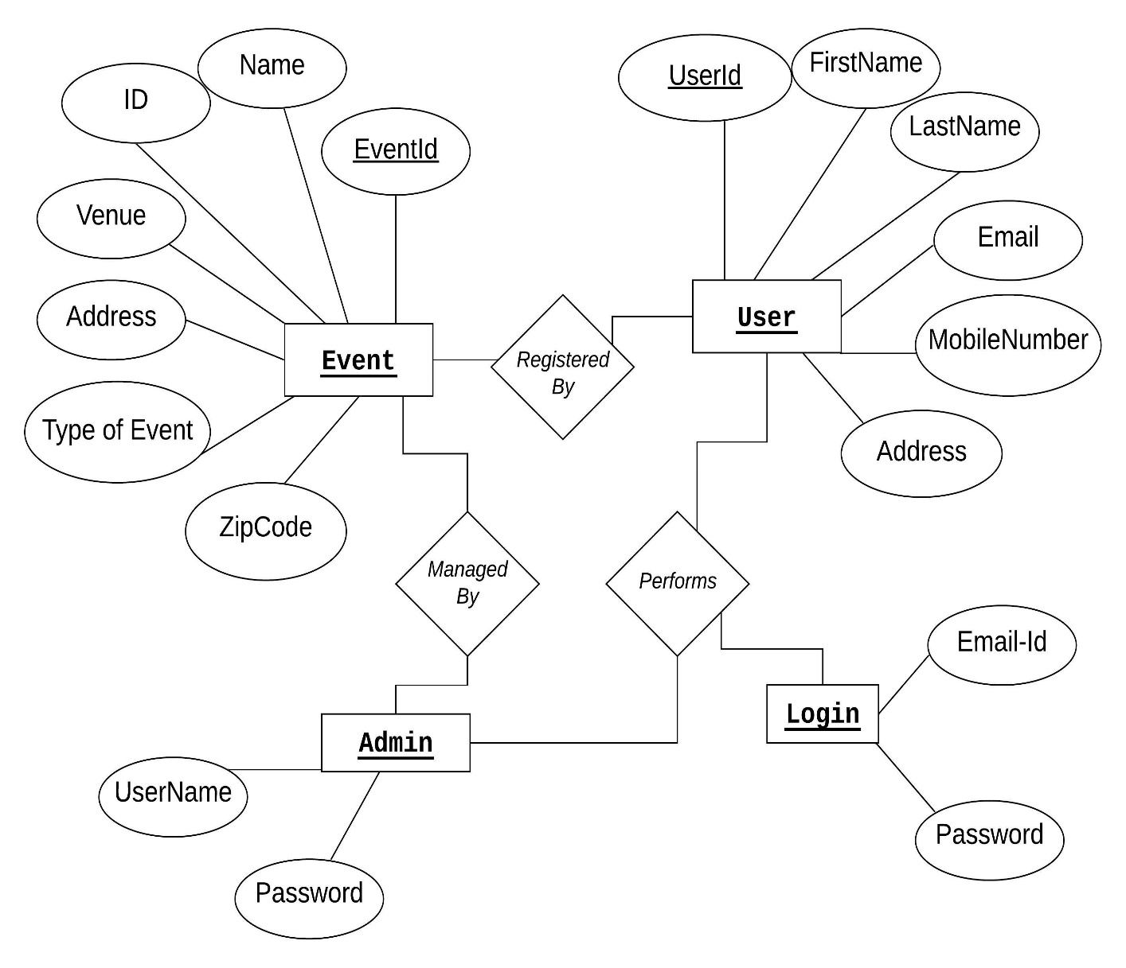

**Fig.1 E-R Diagram**

**3.1.2 CLASS DIAGRAM:**

UML class diagrams: Class diagrams are the foremost building blocks of each object-oriented methods. The class diagram can be used to show the classes, relationships, interface, association, and association.

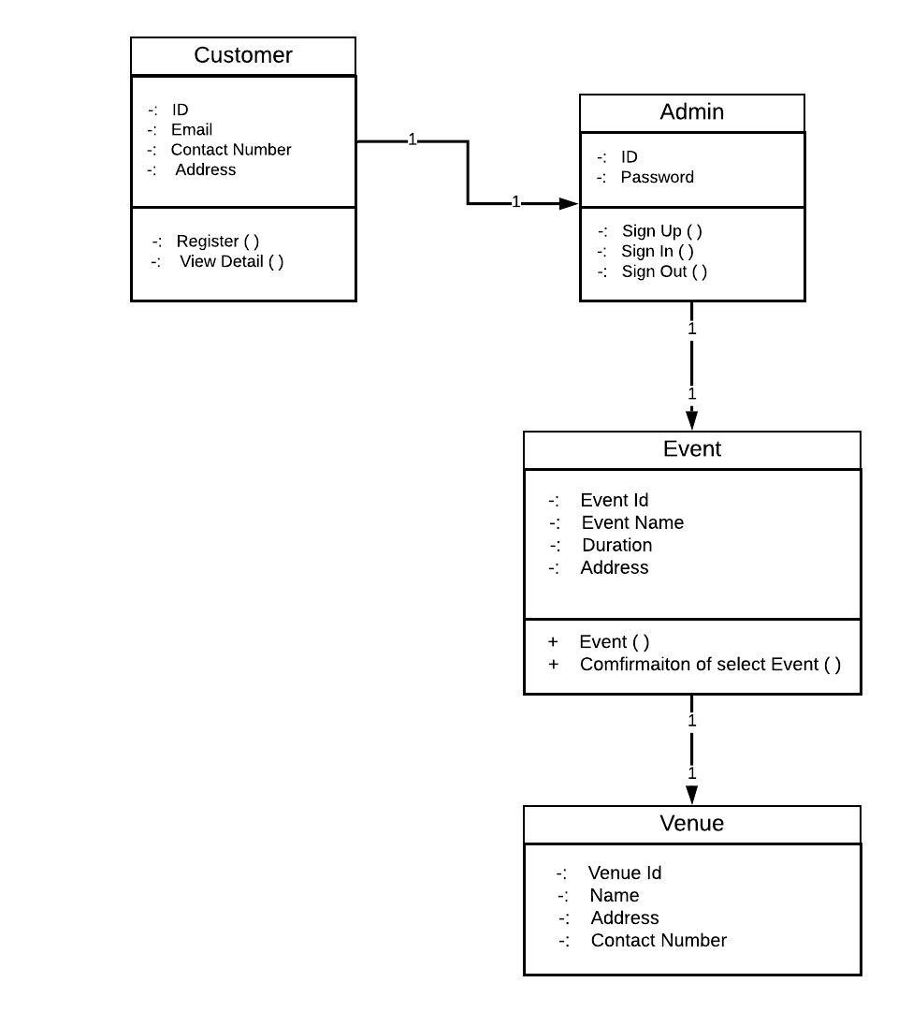

**Fig.2 Class Diagram**

**3.1.3 USE-CASE DIAGRAM:**

Use case diagram is a behavioral UML diagram type and frequently used to scrutinize various systems. They enable you to envision the unlike types of roles in a system and how those roles cooperate with the system.

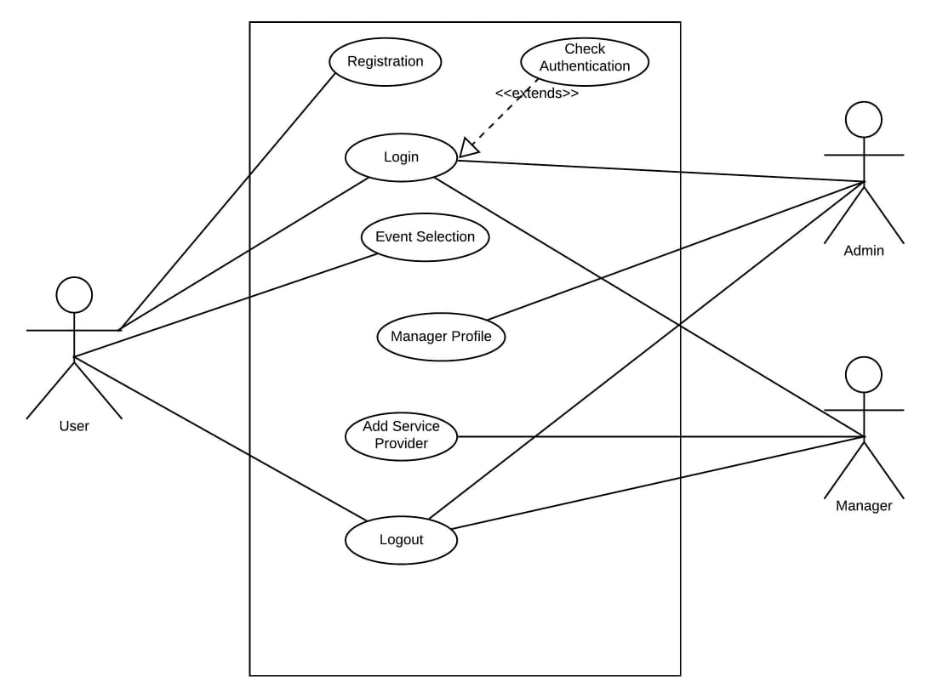

**Fig. 3 Use-Case Diagram**

**3.1.4 DFD DIAGRAM:**

A Data Flow Diagram (DFD) is conventional visual depiction of the information flows within a system which are used to graphically signify the flow of data in an information system by recitation the activities involved in transferring data from input to data storage and reports invention.

A level 0 data flow diagram (DFD), also well-known as a context diagram, shows a data system as entire and accent the way it interacts with peripheral entities.

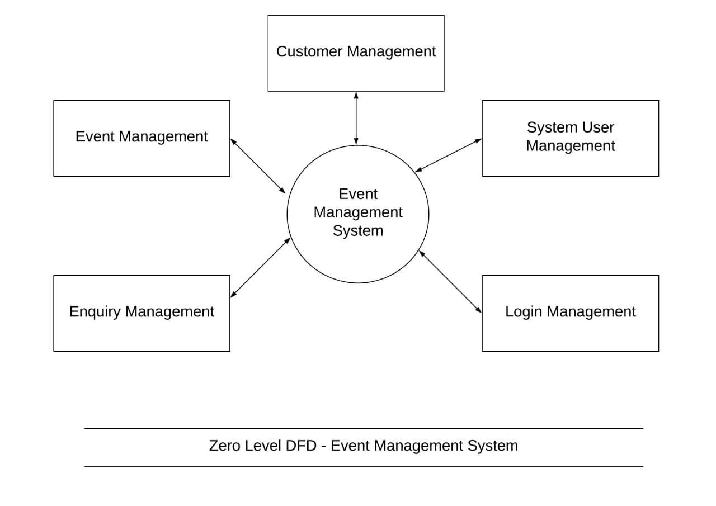

**Fig.4.1 DFD Level 0**

The Level 1 DFD shows how the structure is separated into sub-structures, each of which handles with single or further of the data flow to or from an external agent, and which collectively provide all of the functionality of the structure as a whole.

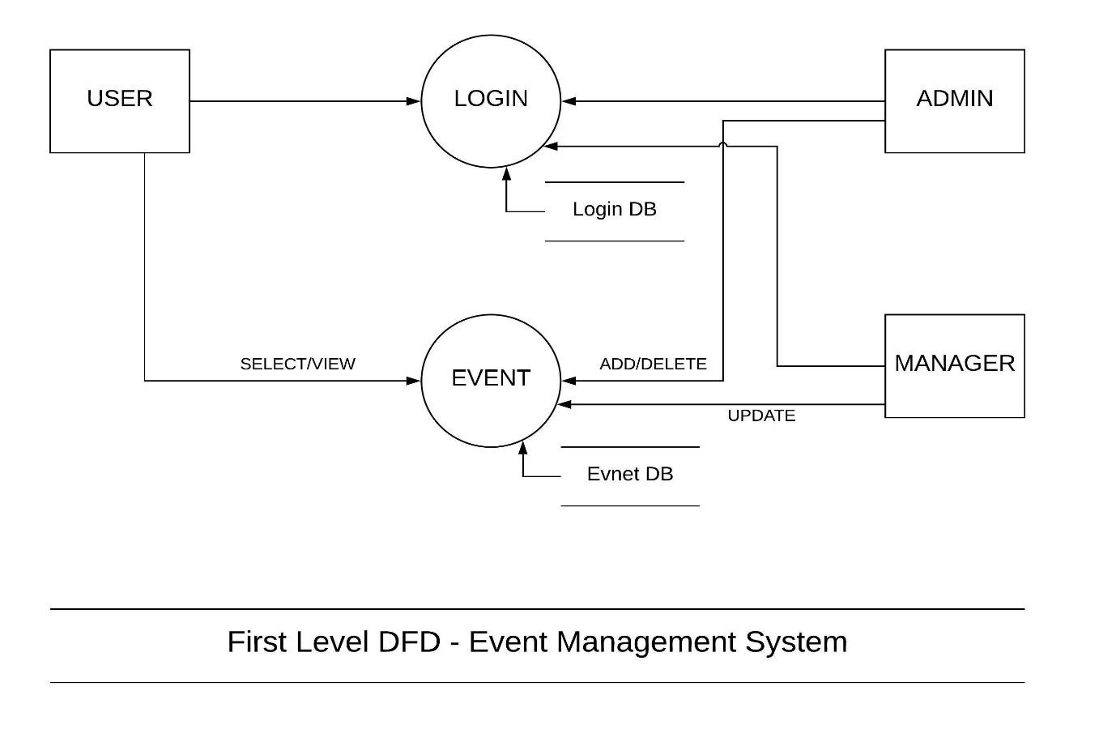

**Fig.4.2 DFD1st Level**

DFD Level 2: If a procedure with a set of data flow linking between a few peripheral entities, we could first remove that particular procedure and the connected external entities into a separate diagram similar to a context diagram, before you filter the process into a split level of DFD; and by this way you can guarantee the consistency between them is much easier.

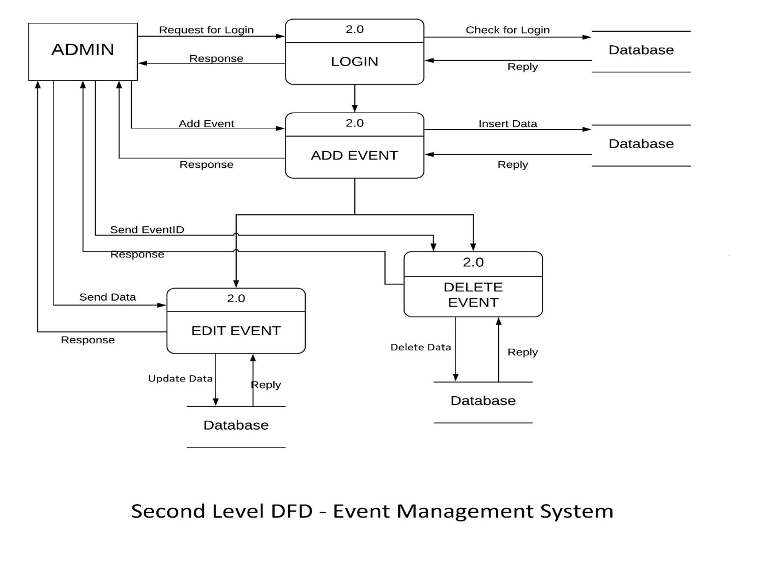

**Fig.4.3 2nd Level DFD**

**3.1.5 ACTIVITYDIAGRAM:**

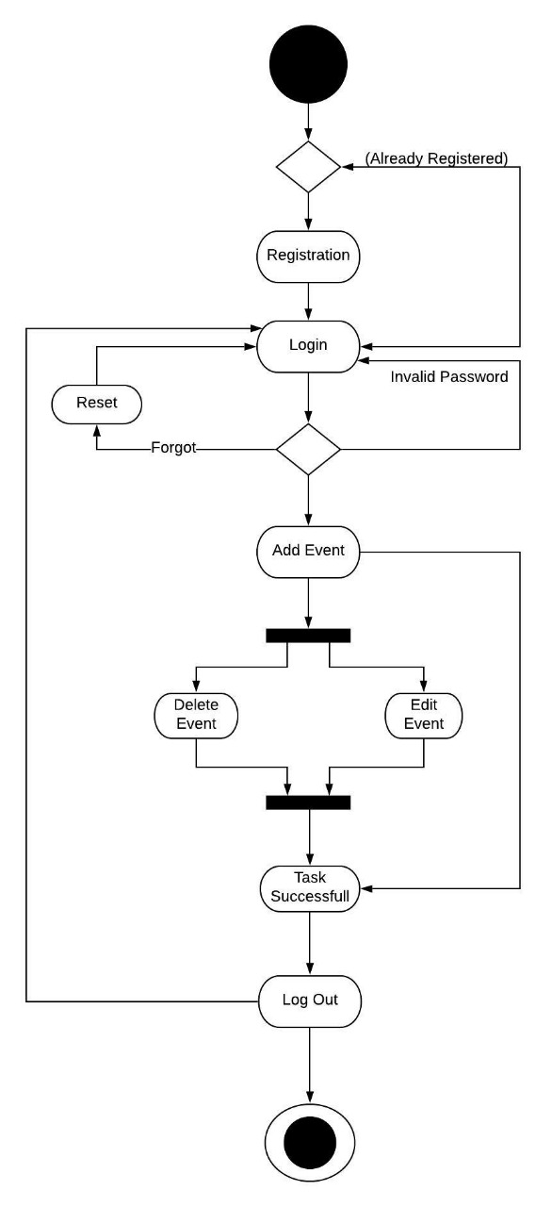

**Fig. 5 Activity Diagram**

**3.1.6 SEQUENCE DIAGRAM:**

Sequence diagrams are a sort of Unified Modeling Language (UML) diagram that shows communications over time. They could map out complex architecture, but they can also be surprisingly easy to create.

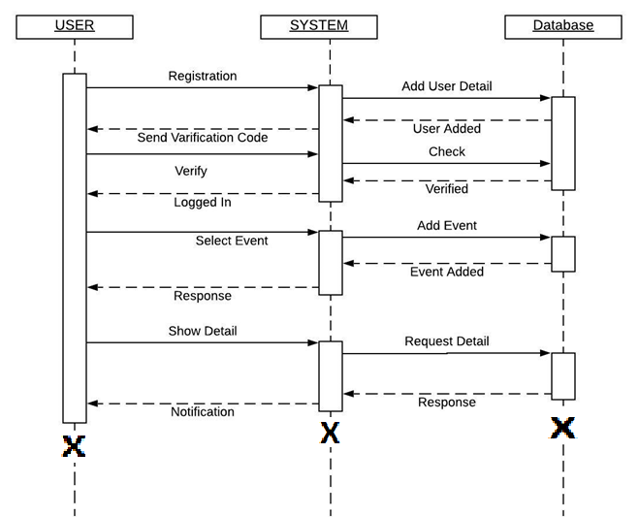

**Fig. 6 Sequence Diagram**

**CHAPTER: 4**

**CANVAS EXERCISE**

**4.1 AEIOU Canvas:**

This exercise was to perform observations and deduct information from them relating to the provided frameworks. The whole summary of this exercise can be watched in the provided image.

• **Activities**:

▪ Create Event

▪ Finding Best Service Provider.

▪ Event Organization.

▪ Event Notification

• **Environment**:

▪ Lack of Knowledge about online system

▪ problem of organizing event

▪ More time-consuming process

• **Interaction**:

▪ User with Event Manager

▪ Event Manager to Sponsors

▪ Event Manager to Service Provider

• **Objects**:

▪ Venue

▪ Center

▪ Event Manager

▪ Admin Office

▪ Service Office

**• Users:**

▪ Customer

▪ Event Manager

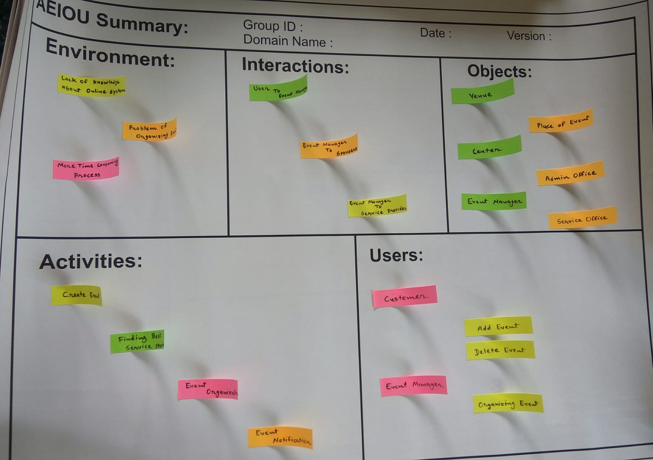

**Fig.7 AEIOU Canvas**

**4.2: Empathy Mapping Canvas**

**Empathize: Understand Users**

• A large number of peoples use the internet every day or we can say that the peoples are mostly spending their time on internet surfing.

• So, the peoples that allows user to interact with the internet is the Web Browser, which is an application used to view web pages.

• So, the peoples are using this application to view the web pages and for downloading data from web pages or for uploading their data to the pages.

**User**

• Customer

• Service Provider

**Stakeholder**

• Sponsor

• Organizer

• Customer

**Activities**

• Registration

• Log In

• Add Event

• Notification

• Delete Event

**Story boarding:**

**Happy story:**

I am Vinod. I am businessman. We often have to organize various events, and because of this website we get all the resources at a single place instead of wandering around for this.

**Happy story:**

I am Parth and I am Service Provider because of this system, I can easily know about the various events which users wants to organize. So, this system is effective and saves time and cost of the user.

**Sad story:**

I am Rahul and I want to organize an event, but I can’t get the proper benefits of this system due to lack of online system, computer and internet.

**Sad story:**

I am Navin. I have small business of Event Management. Because of this online system we are not getting regular work. So, it reduces the employment.

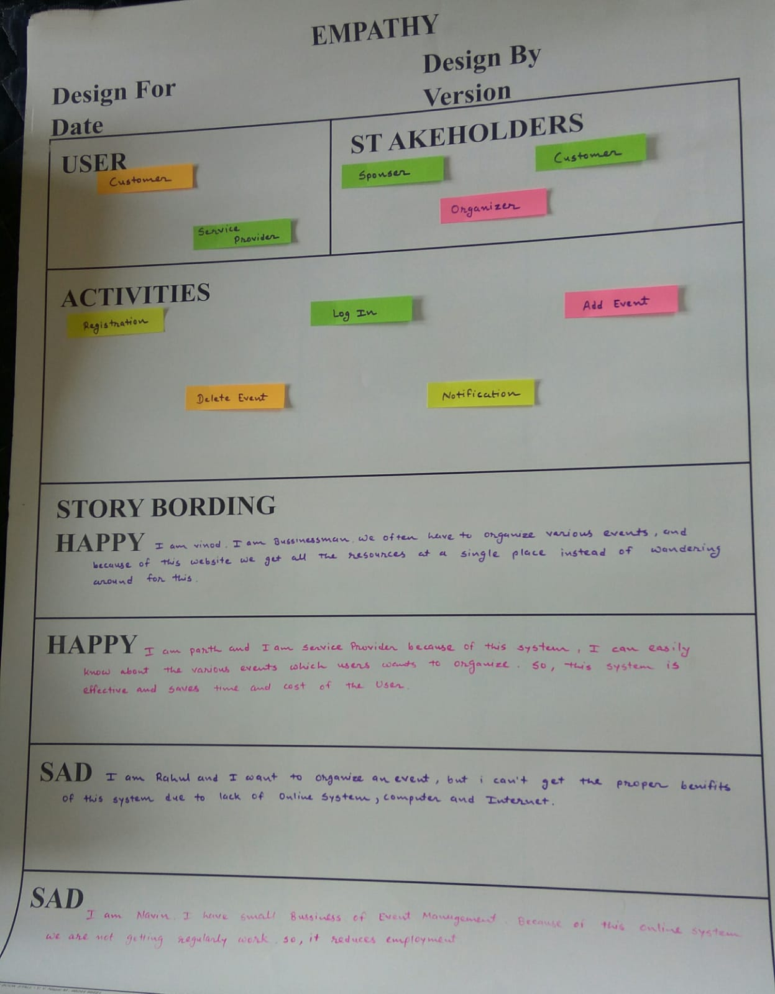

**Fig.8 Empathy Mapping Canvas**

**4.3: Ideation Canvas**

Now this canvas exercise was to focus on the idea of our project. The ending consequence for this was to get a clear idea about the product that we will develop and the general uses which can be related to it. We defined all the probable users that have a chance of utilizing our product.

**People:**

• User

• Service Provider

• Event Manager

**Activities:**

• Login

• Registration

• Add Event

• Delete Event

• Notification

**Props/ Tool/ Object/ Equipment:**

• Database

• Computer

• Internet

• ASP.Net

**Situation/Context/Location:**

• Venue

• Interaction Point

• Center

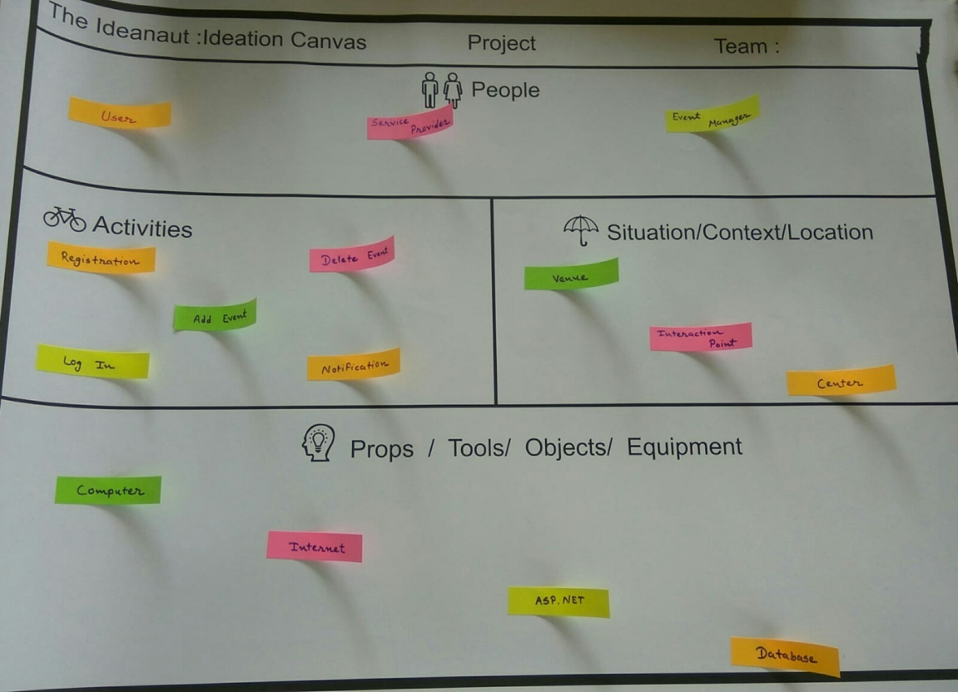

**Fig.9 Ideation Canvas**

**4.4: Product Development Canvas**

The final evaluation and concept of our product design are explained in this canvas. Describing the presented sections of this canvas in brief as per the order in which they are noted.

**Purpose:**

• Event Management

• Digitalization

• Reduce Effort

• Reduce Time

**People:**

• User

• Service Provider

• Event Manager

**Product Experience:**

• Easy to use

• Low cost

**Components:**

• Computer

• My Sql

• Internet

• MVC Framework

**Product Features:**

• Registration

• Login

• Multipurpose Event

• Notification

**Product Function:**

• Information about various events

• Getting better service provider

• online management

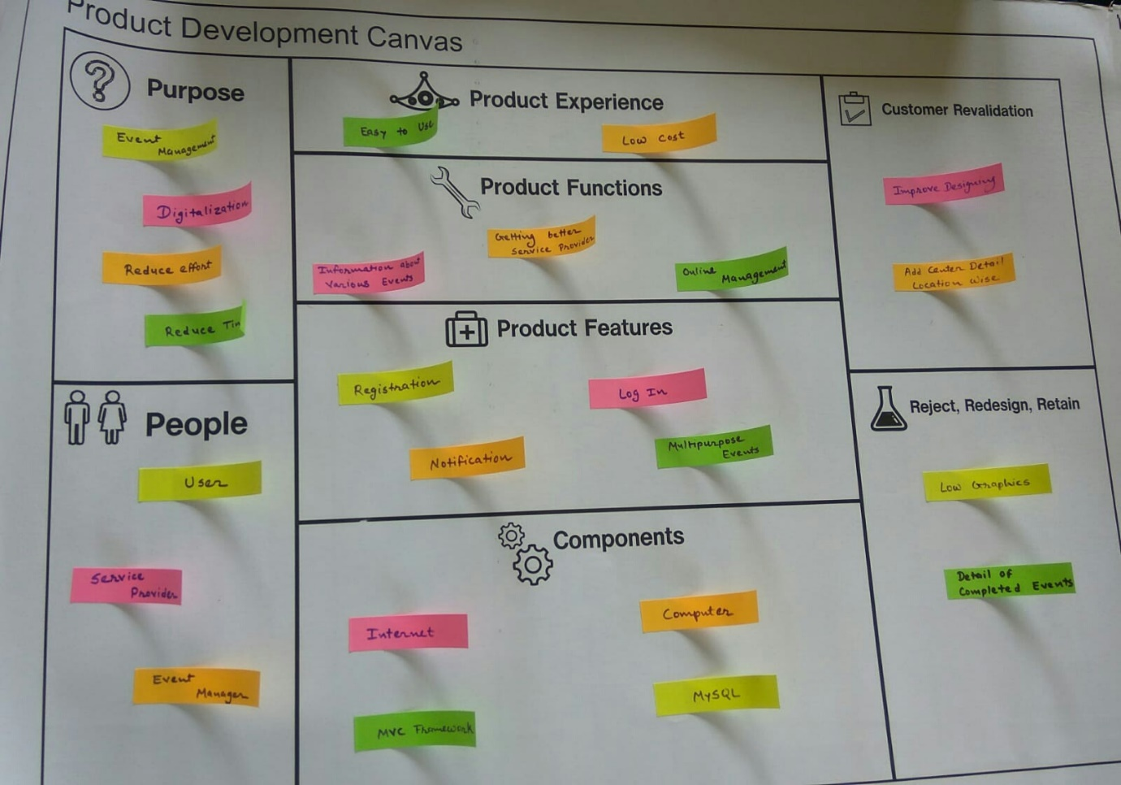

**Fig.10 Product Development Canvas**

**CHAPTER: 5**

**RESULTS**

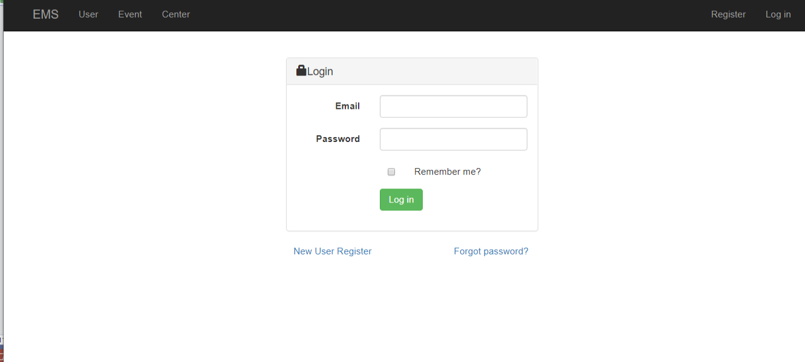 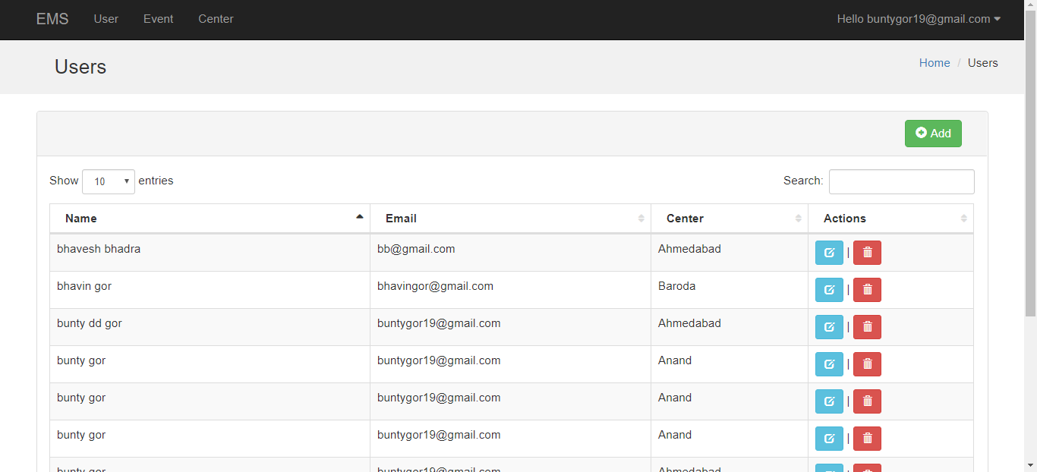 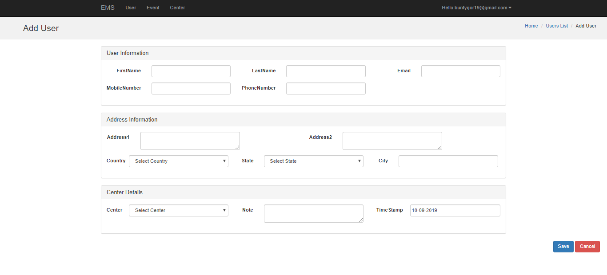 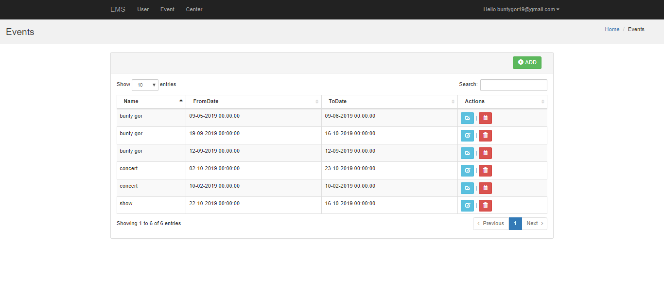 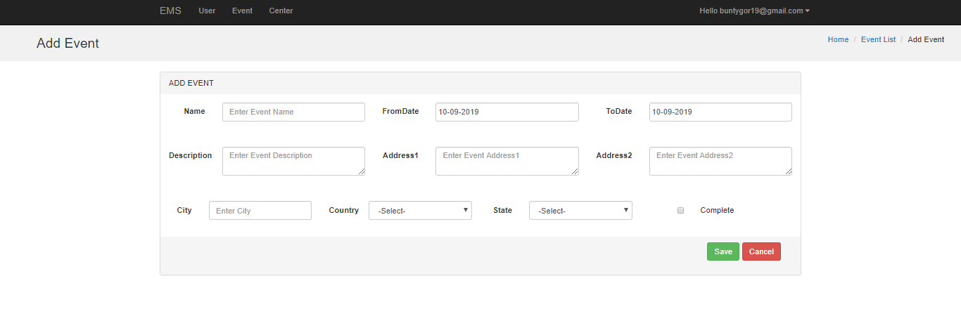

**5.2 Future Enhancement**

* Chatting between Customer and Employee
* Online Payment Method